Painted Cube Problem 1

Consider a 3X3X3 cube. If corner cubes of one face are removed and then the cube is painted on all sides. The cube is then cut into 27 small cubes. Find

1. Number of 3 side painted small cube(s)
2. Number of 2 side painted small cube(s)
3. Number of 1 side painted small cube(s)
4. Number of no side painted small cube(s)

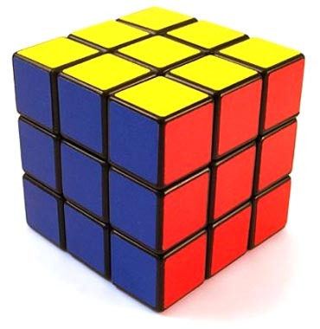

Painted Cube Problem 2

Consider a 3X3X3 cube. If corner cubes are removed and then the cube is painted on all sides. The cube is then cut into 27 small cubes. Find

1. Number of 3 side painted small cube(s)
2. Number of 2 side painted small cube(s)
3. Number of 1 side painted small cube(s)
4. Number of no side painted small cube(s)

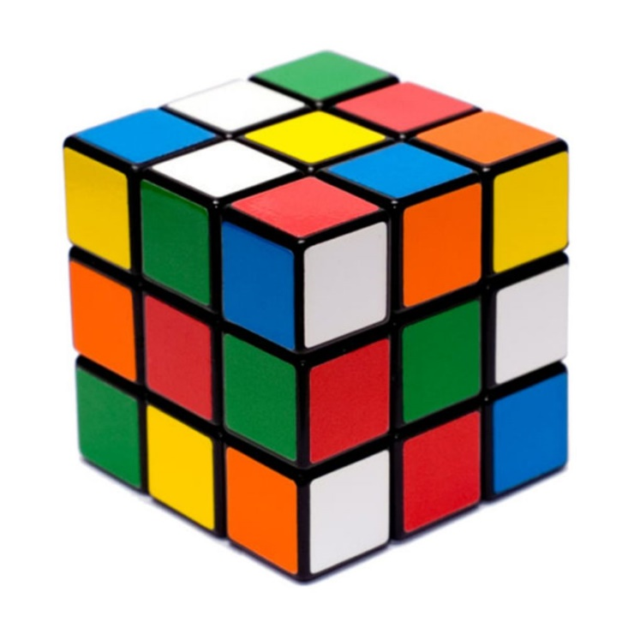

Painted Cube Problem 3

Consider a 3X3X3 cube. If line of cubes on all 4 corners are removed and then the cube is painted on all sides. The cube is then cut into 27 small cubes. Find

1. Number of 3 side painted small cube(s)
2. Number of 2 side painted small cube(s)
3. Number of 1 side painted small cube(s)
4. Number of no side painted small cube(s)

